DA Lab 3
Time Series Analysis of Death Due to Lung Cancer Dataset

Name: Dheeraj Chaudhary

Roll: 17BCS009

library(ggplot2)
library(Metrics)
library(forecast)
library(reshape)
data("mdeaths")
mdeaths
######## OUTPUT > mdeaths
Jan Feb Mar Apr May Jun Jul Aug Sep Oct Nov Dec
1974 2134 1863 1877 1877 1492 1249 1280 1131 1209 1492 1621 1846
1975 2103 2137 2153 1833 1403 1288 1186 1133 1053 1347 1545 2066
1976 2020 2750 2283 1479 1189 1160 1113 970 999 1208 1467 2059
1977 2240 1634 1722 1801 1246 1162 1087 1013 959 1179 1229 1655
1978 2019 2284 1942 1423 1340 1187 1098 1004 970 1140 1110 1812
1979 2263 1820 1846 1531 1215 1075 1056 975 940 1081 1294 1341

start(mdeaths)
1974 1

end(mdeaths)
1979 12

############ TIME SERIES OBJECT OF THE DATA ###############
my_Object <- ts(mdeaths, start=1974 ,frequency = 12)
Object
###### Check whether it is an object or not
is.ts(my_Object)
###### OUTPUT
[1] TRUE

###### PLOT OF MY DATA ########
ts.plot(my_Object, main="Deaths From lung disease",ylab ="Monthly Total mean Deaths")
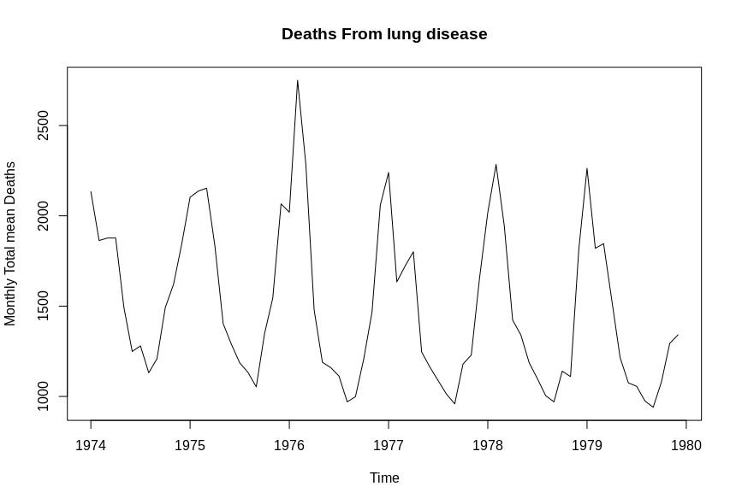

###### PLOT OF MY DATA with adding a horizontal regression line in the plot ########
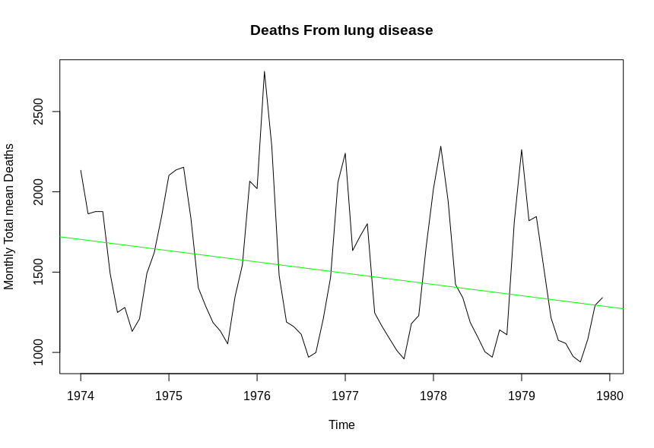
abline(reg = lm(my_Object~time(Object)),col="green")

#################### PLOT OF YEARLY MEAN VALUES ARE #############
plot(aggregate(my_Object,FUN = mean))
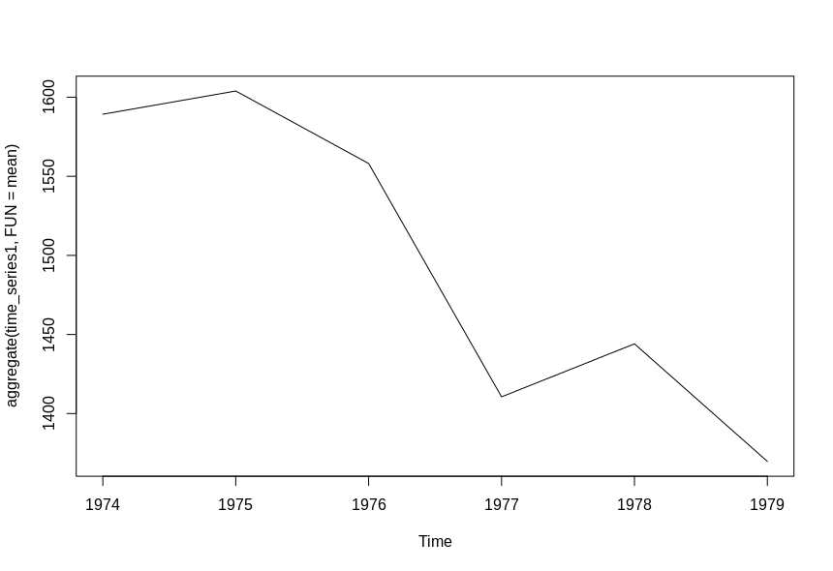
################### PLOT OF MONTHLY BOX PLOTS ARE #################
boxplot(time_series1~cycle(time_series1),xlab="Month",ylab = "Deaths",main = "Death from lung disease")
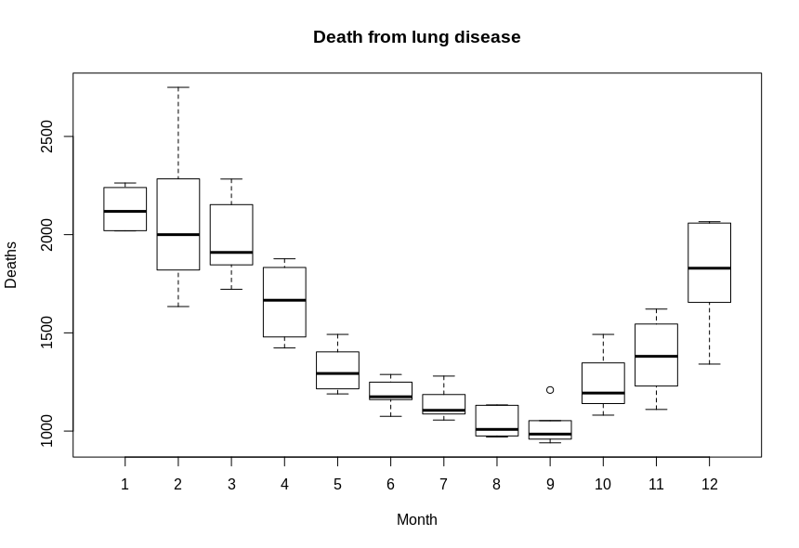

################ DECOMPOSING THE ABOVE TIME SERIES USING STL FUNCTIONS ##########

stlts <- stl(time_series1, s.window = "periodic")
plot(stlts)
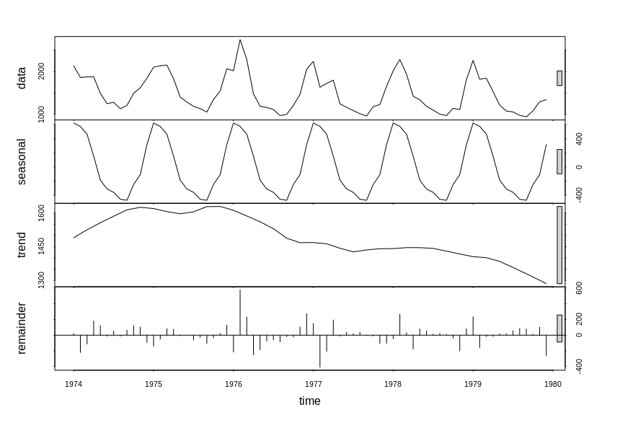
############### PLOTTING TREND GRAPH SEPARATELY #################
stlts$trend <- stlts$time.series[,2]
plot(stlts$trend)
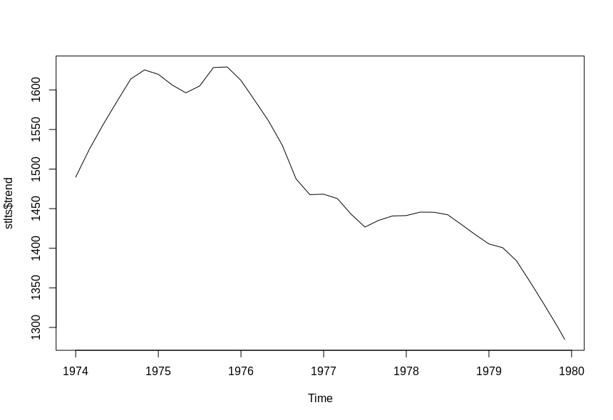
################# TO CHECK SEASONALITY ######################
stlts$seasonal <- stlts$time.series[,1]
plot(stlts$seasonal)
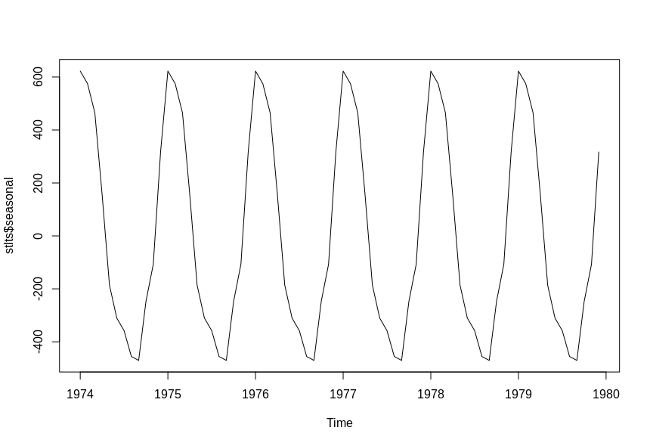
############## RESIDUE AFTER REMOVING THE TREND AND SEASONALITY ##########

stlts$residue <- (time_series1 -(stlts$trend + stlts$seasona))
plot(stlts$residue,main = "Residue after removing trend and seasonality",col = "green")
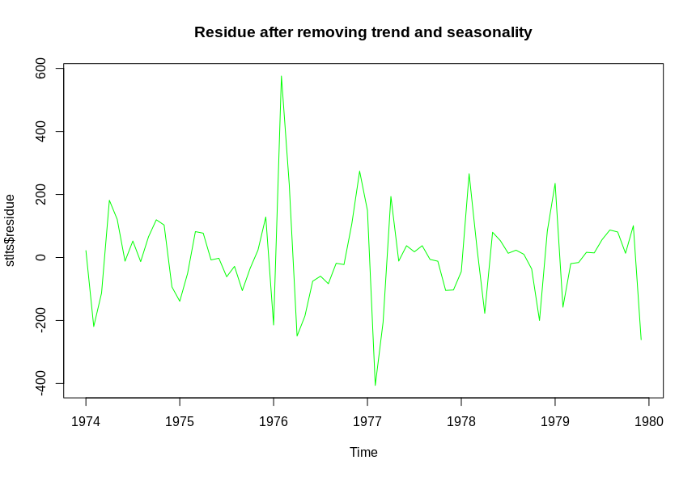
############## MODEL OF THE DATA USING HOLTWINTER METHOD FOR 75% OF DATA ########

